Mujde Ipek
mujdeipek@outlook.com
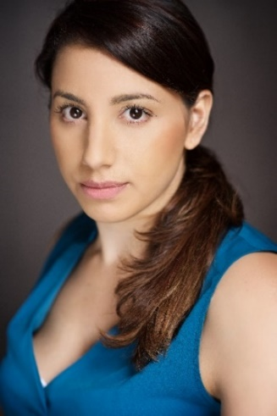
Height: 5’ 5”
Eye Colour: Dark Brown
Hair Colour: Chocolate Brown
Ethnicity: Turkish Cypriot
Equity Number: M00276371

Training
o Acting - Rose Bruford College 2015 – 2017
o Acting - Arts Educational School 2015 – 2016
o Acting, Stage Combat, MT, Acting to Camera - American Academy of Dramatic Arts, Los Angeles 2007
o Movie Martial Arts Workshop – Stage combat, fight choreography
and firearms in TV/Film

Experience at College
Role Play Director Venue
Liz That Almost Unnameable Lust Tony James Barn Theatre
Mary Consensual Tony James Barn Theatre
Beatrice Much ado about nothing Jade Allen Rose Bruford
Ismene Antigone Tony James Rose Bruford
Reverend Parris & Abigail Williams The Crucible Laurence Greiner Rose Bruford
Danny Vera Vera Vera Edward Hulme Arts Educational
Paulina Death and the Maiden Yvonne Letchford Orpington College
Woman 4.48 Psychosis Rebecca Hunt Orpington College
Phillip Orphans Judith Bohannan American Academy

Experience outside College
Role Play Director Venue
Cinderella Cinderella Andrew Nayler Touring
Mother Mary Sister Act Stacey Williams The Pavilion
Various Variety Show Bonnie Langford Her Majesty’s

Film and Television
Role Production Director
Mel – Therapist Addicts Anonymous (TV Pilot) Vicky Alcock
PA Life and Times of Vivienne Vyle David Coyle
Solicitor The Bill Gill Wilkinson
Police Officer Eastenders John Greening

Skills
Accents: South London Accent, General Northern, General American, Californian.
Driving: Full Clean Driving Licence, Police Driver.
Dance: Basic: Line Dance, Salsa Intermediate: Ballet, Jazz, Modern, Contemporary, Dancehall, Ragga. Advanced: Street, Hip-Hop, Tap, Club, Urban, Musical Theatre. Dance Teacher Qualifications - IDTA
Singing: Top A – Bottom G Soprano, Pop, RnB, Musical Theatre, Rap, MC’er, Singer/Songwriter
Miscellaneous: Level 1 Fight Choreography, Martial Arts and Firearms Training and usage Guns: Rubber Gun, H+K USP, Walther CP88, Glock 17, Israeli Desert Eagle, M16 A4. Bike Riding, Weight Lifting, Running (sprint and long distance), Swimming, Tennis, Baseball, Boxing, Aerobics, Aerobics/Dance/Singing Teacher, Touch typing, Policing Skills, TV Presenting

